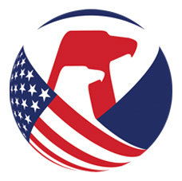U.S. Consumer Product Safety Commission – Recall

Release Date: April 19, 2023
Release Number: 23-DRAFT
Bagno Milano Recalls Children’s Robes Due to Violation of Federal Flammability Standards and Burn Hazard
Recall Summary

Name of Product: Children’s robes

Hazard: The children’s robes fail to meet the federal flammability standards for children’s sleepwear, posing a risk of burn injuries to children.

Remedy: Refund
Consumers should immediately take the recalled robes away from children, stop using them and contact Bagno Milano for a full refund. Consumers who purchased the robes are to destroy the robes by cutting them both vertically and horizontally and disposing of them in accordance with local state recycling laws. Consumers should send an image of the destroyed recalled robes to Bagno Milano by email at support@bagnomilanousa.com. Upon receipt of the photo, consumers will be issued a full refund of the purchase price. Consumers who purchased the robes from Amazon.com will be contacted through Amazon’s messaging platform. Consumers who purchased the robes directly from Bagno Milano’s website will be contacted via mail or email.
Consumer Contact:
Bagno Milano toll-free at 1800-655-3078 from 10 a.m. to 6 p.m. ET Monday through Friday, email at support@bagnomilanousa.com or online at INSERT DIRECT LINK TO RECALL PAGE or INSERT DIRECT LINK TO GENERAL WEBSITE and click on “Product Recall” “Recall Information” “Important Recall Information” at the top/bottom of the homepage for more information.
Recall Details

Units: About 3,590

Description:
This recall involves “Natura Coton” branded children’s 100% cotton terry cloth robes. The robes are long-sleeved, hooded and have two front pockets and two side seam belts for tying the robe together in the front. They were sold in sizes 1 through 13 years and in the following colors: White, Grey, Cream, Blue, Navy, Purple, Pink, and Orange. The neck label states “Made in Turkey” and “100% Cotton” and Washing instructions are printed on a sewn-in label.

Incidents/Injuries: None reported

Sold at: Online at www.bagnomilanousa.com and www.amazon.com from June 2022 through March 2023 for between $19.95 and $46.95, depending on the size.

Importer: Bagno Milano LLC of Holiday, Florida
Manufactured in: Turkey

Individual Commissioners may have statements related to this topic. Please visit www.cpsc.gov/commissioners to search for statements related to this or other topics.

Photos

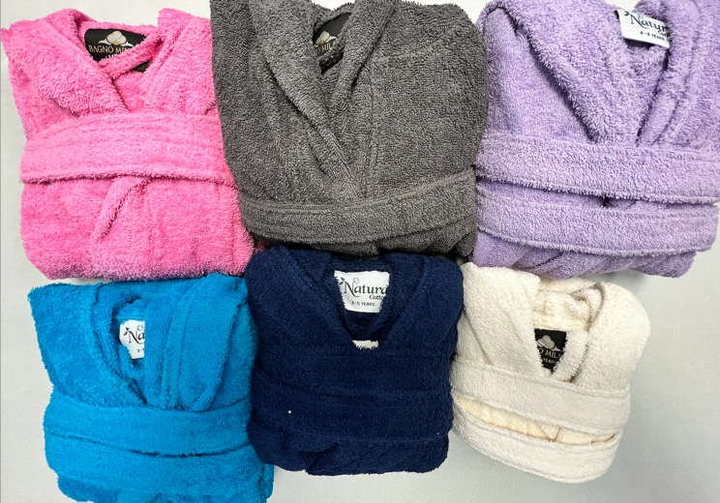

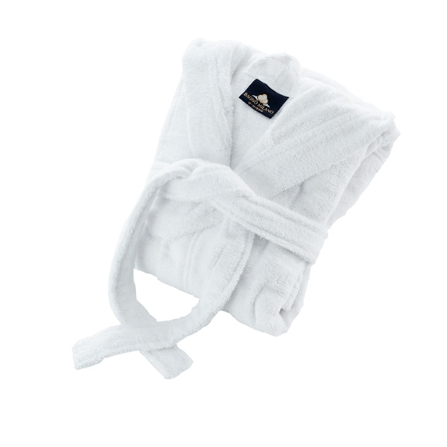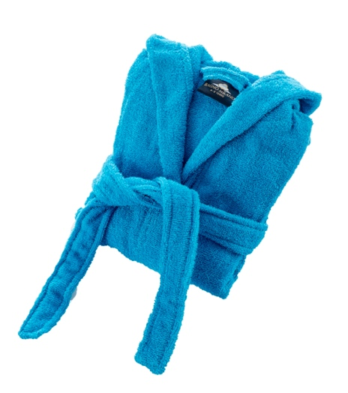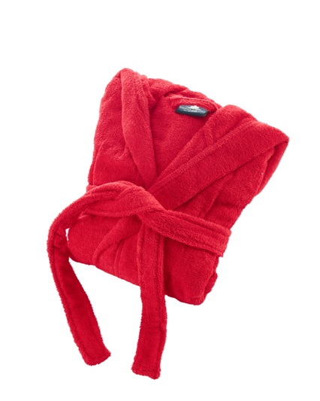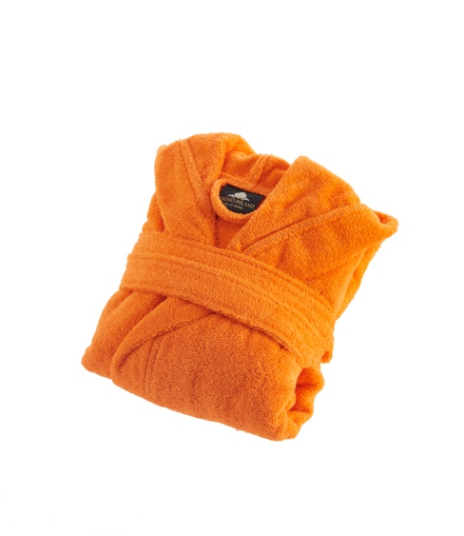

About the U.S. CPSC
The U.S. Consumer Product Safety Commission (CPSC) is charged with protecting the public from unreasonable risk of injury or death associated with the use of thousands of types of consumer products. Deaths, injuries, and property damage from consumer product-related incidents cost the nation more than $1 trillion annually. CPSC's work to ensure the safety of consumer products has contributed to a decline in the rate of injuries associated with consumer products over the past 50 years.

Federal law prohibits any person from selling products subject to a Commission ordered recall or a voluntary recall undertaken in consultation with the CPSC.

For lifesaving information:
- Visit CPSC.gov.
- Sign up to receive our e-mail alerts.
- Follow us on Facebook, Instagram @USCPSC and Twitter @USCPSC.
- Report a dangerous product or a product-related injury on www.SaferProducts.gov.
- Call CPSC’s Hotline at 800-638-2772 (TTY 301-595-7054).
- Contact a media specialist.

